# UPDATEs TO SPECIFICATION DOCUMENT

## TIMELINE & BUDGET

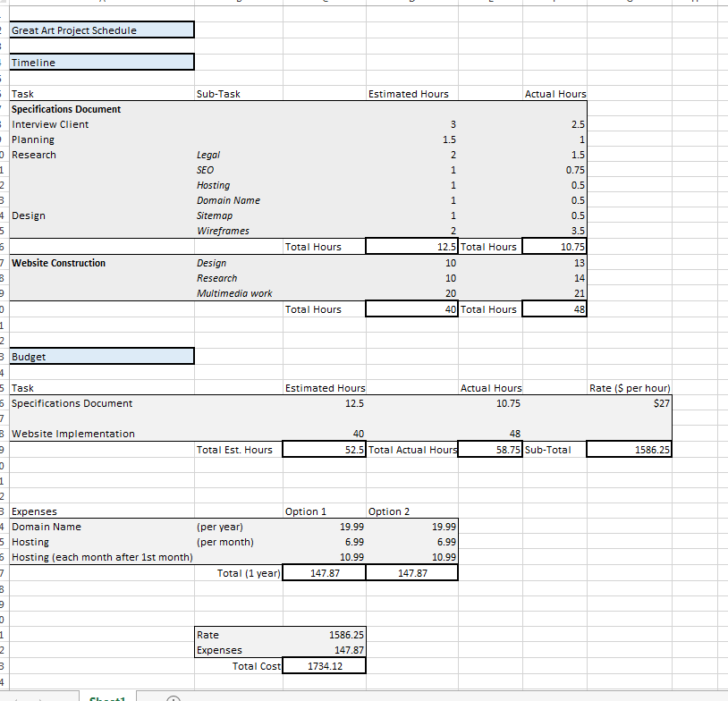

## COPYRIGHT MATERIAL

I sourced all of the artworks and information from these websites.

* <http://www.gretchenalbrecht.com/>
* <http://tworooms.co.nz/artists/gretchen-albrecht/>
* <http://www.nadenemilnegallery.com/artists/Gretchen-Albrecht>

## NOTES & CHANGES

* A Blog page was added because it was accidentally left out of the initial wireframe designs.
* Instead of using a Logo the header was adjusted to make more sense in regards to the purpose of the website.
* Social Media, Blog Posts, and News Items are partially placeholder for the moment, but once the website goes live the social media functionalities can be easily integrated, and the Blog and News areas can be populated with actual content.

## CODE VALIDATION

All HTML pages and CSS Stylesheet validated with no errors.

